**PEANUT BUTTER JELLY SANDWICH**

**Objective**

This document focuses on the step by step process of making a peanut butter jelly sandwich. Though the main ingredients for the sandwich are simple, making this American legacy dish requires skills and knowledge.

**What is Peanut Butter Sandwich ?**

Peanut butter jelly sandwich is one of the most common home preparations in America. Every morning, Americans prepare hundreds of thousands of peanut butter sandwiches as breakfast or lunch for school-going kids, for office-going workers or for college-going adolescents. Its small ingredients and easy-to-prepare recipe has made it a favorite snack for millions of American house-holds. People love it but do not know the right way to prepare it. Every person has his/her own way of making the American delicacy but without a proper procedure, it is nearly impossible for anyone to make the famous sandwich the way it should be.

Dr. Ambrose Straub, a St Louise physician, crushed peanuts into a paste for his geriatric patients with bad teeth. At the Chicago World’s Fair, peanut butter gained popularity. Julia David Chandler, in her book The Boston Cooking School Magazine for Culinary Science and Domestic Science published the first known recipe for peanut butter jelly sandwich, which was published in 1901. During the 20’s and 30’s, creamy peanut butter was commercialized, which led to the domestic adoption of peanut butter sandwich. During World War 2, American soldiers started adding jelly to their peanut butters to make it more palatable. [1]

**Recipe**

Ingredients required to make a peanut butter and jelly (or jam) sandwich.:

1. 3 slices of Bread : White or Brown (of your choice) but it should be soft bread; milk bread preferred.
2. Peanut butter
3. Few roasted peanuts
4. Jelly or jam: Strawberry, apricot, blackberry or any other jam but its preferred that **jam should be a bit acidic**. Few people use **Nutella** as a spread which also works fine but then at the end, the whole taste of sandwich skews towards sweetness.

Step By Step process to make the sandwich :

1. Take a slice of bread and spread the peanut butter on one side.
2. Crush some roasted peanuts and sprinkle on the slice to add crunchiness to your sandwich.
3. Take the 2nd slice of bread and apply jelly/jam (of your choice) on both sides and place the bread on top of the bread with buttered side up.
4. Take the 3rd bread slice and follow Step 1 & 2 and place it on top of the sandwich made in step 3 (Butter side down).
5. Grill the sandwich for 4 minutes if you want your sandwich hot and crispy or else enjoy your sandwich as it is.

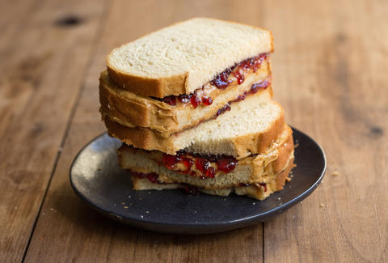[2]

References:

1. <https://whatscookingamerica.net/History/Sandwiches/PeanutButterJellySandwich.htm>
2. <https://www.thrillist.com/eat/nation/important-sandwiches-that-changed-america-forever>